**Stock Price Prediction Using LSTM**

**Nakib Ahmed, Safoan-Bin-Rashid, Sharmin Sultana Moury, Ankur Nahar**

**Abstract: Predicting stock prices has always been of interest to investors and companies, as it reflects investors’ confidence in a company and future potential of a company. Adept and effective prediction systems for stock market values is of immense importance to traders, investors, and analyst for providing indicative information about the future direction of stock market values. Yet it seems unfeasible to make any prior prognosis due to it's seemingly random nature. While researchers and analysts scurry to unriddle effective prediction systems or algorithms, RNN (recurrent neural network), along with LSTM (long short-term memory) have made their way into the research field for stock price predictions due to its capacity to deal with vast amounts of data, and bridge long time lags between inputs through utilizing LSTM. In our project, we present the RNN and LSTM approach to predicting stock market indices.**

**Keywords:** Long short-term memory (LSTM), recurrent neural network (RNN), Google stocks, root mean square error (RMSE), prediction, stock prices

**1. Introduction**

There are numerous complicated financial indicators, as well as highly violent fluctuations of stock market prices. However, as technology is advancing, the scope to gain a steady fortune from the stock market is elevating. These advancments are used by experts to find the most informative indicators to make efficacious predictions. The prediction of market values is of great importance in maximizing the profit of stock purchase options, keeping the risks at a low all the while.

Recurrent neural networks (RNN) have proved one of the most powerful models for processing sequential data.

Long Short-Term memory is one of the most successful RNNs architectures. LSTM introduces the memory cell, a unit of computation that replaces traditional artificial neurons in the hidden layer of the network. With these memory cells, networks are able to effectively associate memories and input remote in time, hence suit to grasp the structure of data dynamically over time with high prediction capacity.

The paper that we have presented, models and predicts the stock returns of Google stocks using LSTM. We collected five years of historical data of Google stocks and used it for the training and validation purposes in our model. In the next section of the paper we have discussed methodology, where we explain each process in detail. After which we have pictorial representations of the analysis that we used. We have also recounted the results we achieved.

**2. Methodology**

Various types of neural networks can be developed by utilizing distinct combinations of factors, like network topology, training method etc. For this experiment, we have considered Recurrent Neural Network and Long Short-Term Memory.

In this section we have discussed the methodology of our system, which consists of several stages as follows:-

Stage 1: Raw Data: In this stage, the historical stock data is collected from https://www.quandl.com/data/NSE, and this historical data is then used for the prediction of future stock prices.

Stage 2: Data Preprocessing: The pre-processing stage involves a) Data discretization: Part of data reduction but with particular importance, especially for numerical data b) Data transformation: Normalization. c) Data cleaning: Fill in missing values. d) Data integration: Integration of data files. After the dataset is transformed into a clean dataset, the dataset is divided into training and testing sets so as to evaluate. Here, the training values are taken as the more recent values. Testing data is kept as 5-10 percent of the total dataset.

Stage 3: Feature Extraction: In this layer, only the features which are to be fed to the neural network are chosen. We will choose the feature from Date, open, high, low, close, and volume.

Stage 4: Training Neural Network: In this stage, the data is fed to the neural network and trained for prediction assigning random biases and weights. Our LSTM model is composed of a sequential input layer followed by 2 LSTM layers and dense layer with ReLU activation and then finally a dense output layer with linear activation function.

The code of the Neural Network implemented in Keras is as follows:

|  |
| --- |
| model = Sequential()    model.add(LSTM(128, input_shape=(layers[1], layers[0]), return_sequences=True))    model.add(LSTM(64, input_shape=(layers[1], layers[0]), return_sequences=False))    model.add(Dense(16,init='uniform',activation='relu'))    model.add(Dense(1,init='uniform',activation='linear')) |

Stage 5: Output Generation: In this layer, the output value generated by the output layer of the RNN is compared with the target value. The error or the difference between the target and the obtained output value is minimized by using back propagation algorithm which adjusts the weights and the biases of the network.

**3. Analysis**

For analyzing the efficiency of the system, we have used the Root Mean Square Error(RMSE). The error or the difference between the target and the obtained output value is minimized by using RMSE value. RMSE is the square root of the mean/average of the square of all of the errors. The use of RMSE is highly common, and it makes for an excellent general purpose error metric for numerical predictions. Compared to the similar Mean Absolute Error, RMSE amplifies and severely punishes large errors.

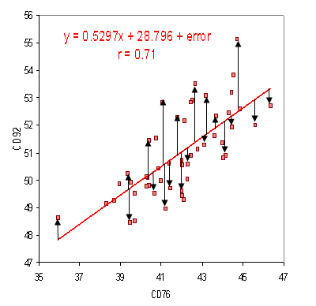

**Figure 3.1: RMSE formula diagram**

**4. Experimental Work**

● Dataset description: We have acquired the data from <https://www.quandl.com>, and have collected historical stock data of Google stocks from the National stock exchange. Apace with this we have collected daily datasets and kept a window size of 22 days. Datas range from 01.01.2011 to 31.12.2016.

● Sequence data: We got 1312 sequences from 01.01.2011 to 31.12.2016. From these data set we used 1180 samples for training purpose and 132 samples for validation purpose.

● Training Detail: For training the model we used RMSprop as the optimizer and normalized each vector of the sequence. We used Google cloud engine as a training platform [Machine type: n1-standard-2 (2 vCPUs, 7.5 GB memory), CPU platform: Intel Ivy Bridge] and used Ubuntu 16.04, Keras (Frontend) and Tensorflow (Backend) as the learning environment.For our experiment, we have used a various set of parameters with a different number of epochs to measure the RMSE of Training and Testing dataset.

**5. Experimental Result**

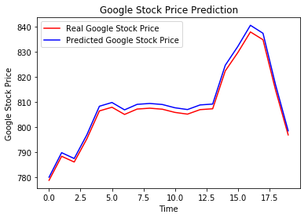

**Figure 5.1:** Initial prediction

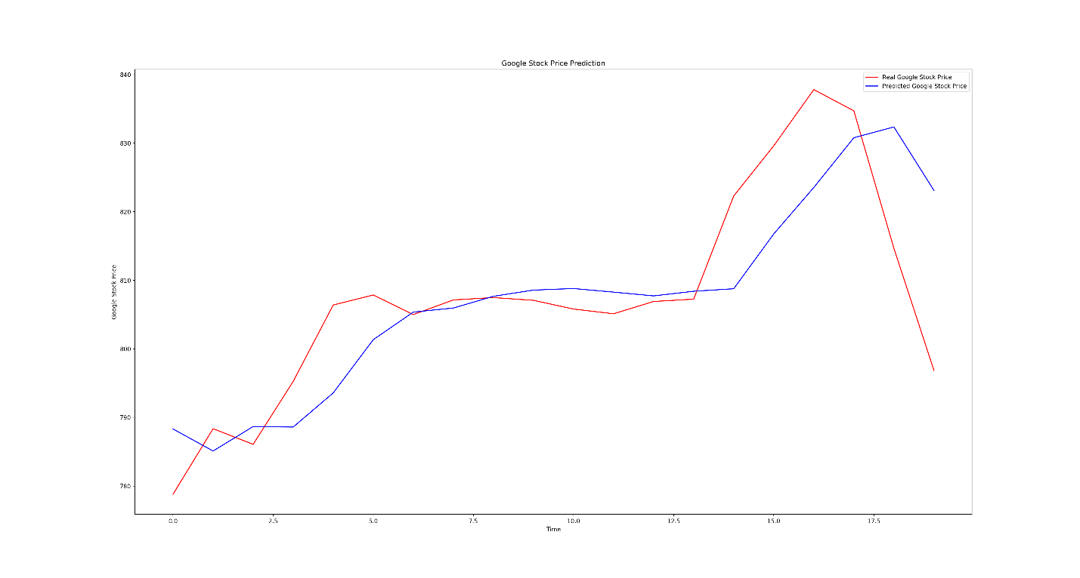

**Figure 5.2:** RNN 20 timesteps 1 LSTM layer

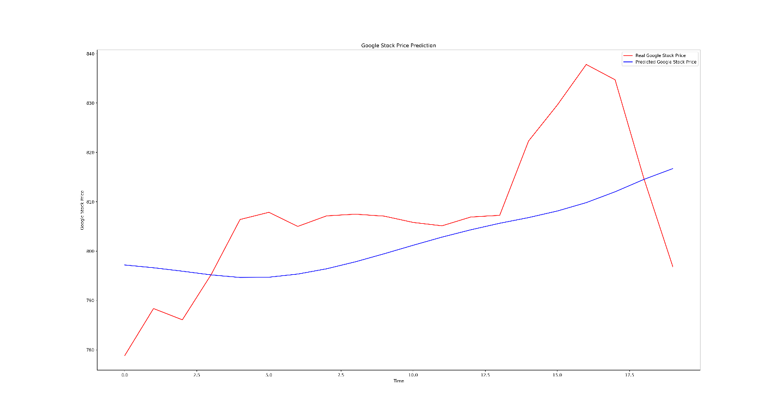

**Figure 5.3:** RNN 20 timesteps 4 LSTM layer

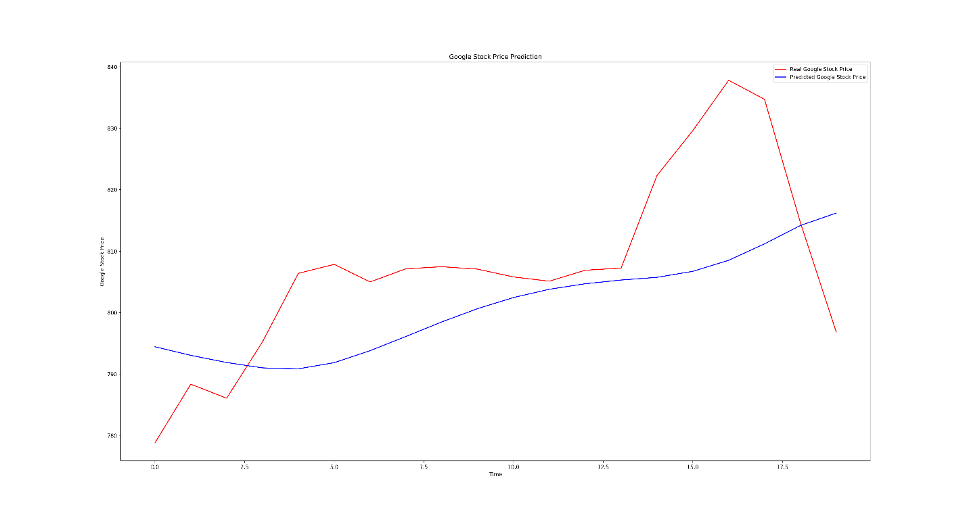

**Figure 5.4:** RNN 60 timesteps 4 LSTM layer

After performing various simulations with varying number of parameters and epochs, we have come to observe, that by taking four feature sets (High/Low/Open/Close) with 500 epochs, we can achieve the best results with training RMSE of 0.00983, and testing RMSE of 0.00859.

**6. Conclusion**

The stock market trading is a rapidly growing enterprise, which is encouraging researchers to find new methods for prediction using new techniques. The forecasting technique is not only helpful for researchers, but is also beneficial to investors, and anyone engaging in stock market operations, and a forecasting model with high accuracy levels is essential in order to attemt predicting the stock indices.

In this assignment, we have used the data we collected to train and predict stock prices using a most precise forecasting technology that implements Recurrent Neural Network and Long Short-Term Memory unit, which is used by helps analysts and researches to fortell, and anyone invested in the stock market to anticipate future prospects of the stock market.

**References**

[1] Rakhi Mahant, Trilok Nath Pandey, Alok Kumar Jagadev, and Satchidananda Dehuri ―Optimized Radial Basis Functional Neural Network for Stock Index Prediction, ‖ International Conference on Electrical, Electronics, and Optimization Techniques (ICEEOT) - 2016.

[2] Kai Chen, Yi Zhou and Fangyan Dai ―A LSTM-based method for stock returns prediction: A case study of China stock market, ‖ IEEE International Conference on Big Data, 2015.

[3] A.U.S.S Pradeep, Soren Goyal, J. A. Bloom, I. J. Cox, and M. Miller, ―Detection of statistical arbitrage using machine learning techniques in Indian Stock market,‖ IIT Kanpur, April 15, 2013.

[4] Prashant S. Chavan, Prof. Dr. Shrishail. T. Patil ―Parameters for Stock Market Prediction,‖ Prashant S Chavan et al, Int.J.Computer Technology & Applications, Vol 4 (2),337-340.

[5] Neelima Budhani, Dr. C. K. Jha, Sandeep K. Budhani―Prediction of Stock Market Using Artificial Neural Network,‖ International Conference on Soft Computing Techniques for Engineering and Technology (ICSCTET)- 2014.

[6] Sharvil Katariya, Saurabh Jain―Stock Price Trend Forecasting using Supervised Learning Methods.

[7] Dhiraj Mundada, Gaurav Chhaparwal, Sachin Chaudhari, and Trupti Bhamare― Stock Value Prediction System, ‖ International Journal on Recent and Innovation Trends in Computing and Communication, April 2015

[8] Hochreiter, Sepp, and Jürgen Schmidhuber― Long short-term memory, ‖ Neural computation 9.8 (1997): 1735-1780